* PRE-MATTER
  + Title Page
    - descriptive title of proposed project
    - make direct reference to RFP
  + Table of Contents (with clickable links to headings formatted using Styles)
* BODY OF THE REPORT
  + Introduction
    - Background (RFP)
    - Problem definition
      * Needs
      * Goals
      * Objectives
      * Constraints
    - Solution introduction
  + Project Plan
    - What you need to find out
      * Detailed description of solution
      * Benefits of solution
    - Research plan
      * Preliminary research done so far
      * Detailed research plan to investigate feasibility
        + Interviews
        + Academic sources
        + UX Analysis
      * Why it should be implemented
      * Gantt Chart
        + Tasks

Completing the Client Report

* + - * + Subtasks
  + Conclusion
    - Final Pitch (attempt approval for the last time)
  + References
    - IEEE style

MEMO

Project Proposal:

# This is a placeholder for the name of our project

____________________________________________________________________________

In response to Ocean Networks Canada request for proposals: RFP# ONC 202301

* This is a subtitle
* descriptive title of proposed project
* make direct reference to RFP

# 1 - Table of Contents

* (with clickable links to headings formatted using Styles)

# 2 - Introduction

* Background (RFP)
* Problem definition
  + Needs
  + Goals
  + Objectives
  + Constraints
* Solution introduction

# 3 - Project Plan

After receiving the RFP, we decided to analyze the problem in more detail, and reached a consensus on how to approach it. Since the desired goal would minimize sound pollution and its harm to Orca populations, we realized what could most efficiently solve the task: targeting the ones that caused the most harm; in this case, ship captains.

## 3.1 - Solution Design

The solution to ONC’s problem would first involve adding new widgets to the Dashboard: an A.I.S of ships and a predictor of killer whales hotspots. Then, these widgets would mix to create a live map, of ease availability to said captains. This map would then compare each ship’s proximity to said hotspots and automatically recommend a safe speed as to produce less sound. With this approach, the Dashboard could establish a healthy balance between marine life and human action by facilitating environmentally-friendly actions while maintaining productivity whenever possible and responsible.

## 3.2 - Research plan

After some initial research [a,b] and an interview with staff from ONC [c] into the nature of the problem, we arrived at the proposed solution. However, this topic requires more research, including but not limited to: (a) feasibility of these widgets, (b) effectiveness in the real world and (c) impact on ships productivity. Here follows a graph detailing our planned approach to investigate further into these topics, including the work already performed:

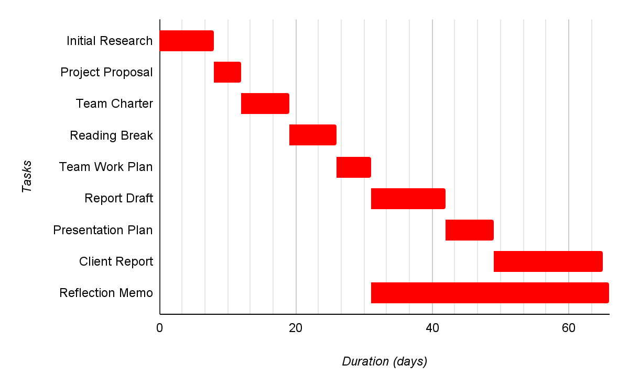

Fig. x. Planned Work Schedule.

Through these various tasks, the team would not only monitor each other’s contributions to the research, but the client report would end up more extensive, detailed and complete. We plan to divide the team into two teams: research and mock-up design. With this approach, the proposal back to the client will include both significant data and a basic representation of what actual implementation could look like.

# 5 - References

* [a] placeholder for “Marine noise pollution and Cetaceans” by Alexis Walsh, Boise State University, ScholarWorks
* [b] placeholder for <https://www.youtube.com/watch?v=UWGdkxNvb34&ab_channel=UVic> // <https://coltonhash.com/acoustic-turbulence/>
* [c] Zoom interview reference placeholder

(propose a solution you would like to investigate further to see if it will effectively solve the client's problem. Describe HOW you propose to complete this research. )

* + Preliminary research done so far
  + Detailed research plan to investigate feasibility
    - Interviews
    - Academic sources
    - UX Analysis
  + Why it should be implemented
  + Gantt Chart
    - Tasks
      * Completing the Client Report
    - Subtasks

# 4 - Conclusion

* Final Pitch (attempt approval for the last time)

# 5 - References

* [a] placeholder for “Marine noise pollution and Cetaceans” by Alexis Walsh, Boise State University, ScholarWorks
* [b] placeholder for <https://www.youtube.com/watch?v=UWGdkxNvb34&ab_channel=UVic>
* [c] Zoom interview reference placeholder